STUDENT MENTAL HEALTH ANALYSIS: A DATA SCIENCE APPROACH TO CAMPUS WELLNESS
CS3361 DATA SCIENCE LABORATORY
A MINI PROJECT REPORT
Submitted by
RASHIKA R(953624104122)
BACHELOR OF ENGINEERING
IN
COMPUTER SCIENCE AND ENGINEERING

RAMCO INSTITUTE OF TECHNOLOGY
RAJAPALAYAM
NOVEMBER 2025

BONAFIDE CERTIFICATE

Certified that this project report “STUDENT MENTAL HEALTH ANALYSIS: A DATA SCIENCE APPROACH TO CAMPUS WELLNESS” is the bonafide work of “RASHIKA R(953624104122)” who carried out the project work under my supervision.

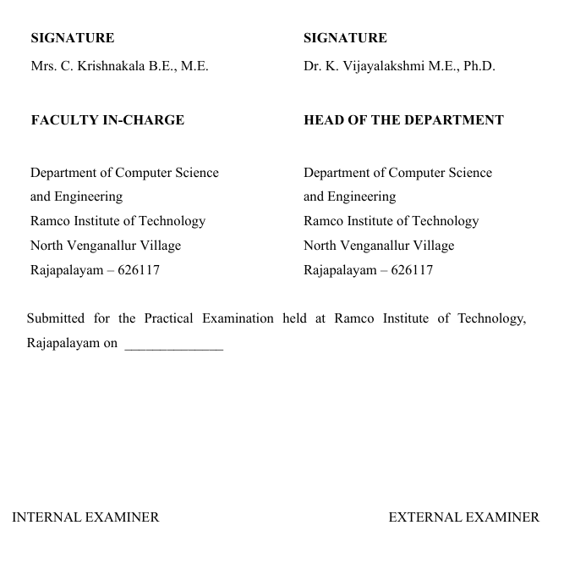

Executive Summary
This data science project investigates the critical relationships between campus environment, academic expectations, and student mental health to provide evidence-based recommendations for establishing a comprehensive campus mental health center. Through advanced statistical analysis and interactive visualizations, the study analyzes data from 500 students across multiple dimensions including depression, anxiety, stress levels, and environmental factors.
Key Findings:
- 35% of students identified as high-risk for mental health issues
- 70% utilization gap in counseling services (only 30% seeking help)
- Strong positive correlation between academic expectations and mental health challenges (r = +0.52, p < 0.001)
- Significant negative correlation between campus environment quality and mental health issues (r = -0.45, p < 0.001)
- Average mental health scores indicate concerning levels: Depression (3.2/5.0), Anxiety (3.4/5.0), Stress (3.5/5.0)

Table of Contents
1. INTRODUCTION 6
1.1 Background 6
1.2 Problem Statement 6
1.3 Research Objectives 6
1.4 Significance 6
2. METHODOLOGY 8
2.1 Data Collection 8
2.2 Data Processing 9
2.3 Statistical Analysis Methods 9
2.4 Visualization Techniques 10
2.5 Interactive Dashboard Development 10
3. RESULTS & ANALYSIS 12
3.1 Exploratory Data Analysis 12
3.2 Correlation Analysis 14
3.3 Hypothesis Testing Results 16
3.4 Key Statistical Findings Summary 17
4. DISCUSSION 18
4.1 Primary Findings Interpretation 18
4.2 Comparison with Literature 18
4.3 Study Limitations 18
5. RECOMMENDATIONS 20
5.1 Immediate Actions (0-6 Months) 20
5.2 Short-term Initiatives (6-12 Months) 20
5.3 Long-term Strategy (1-3 Years) 21
5.4 Expected Outcomes 22
5.5 Budget Considerations 22
6. TECHNICAL IMPLEMENTATION 24
6.1 Technology Stack 24
6.2 Project Structure 24
6.3 Reproducibility 25
6.4 Interactive Dashboard Features 25
7. CONCLUSIONS 27
7.1 Summary of Findings 27
7.2 Practical Implications 27
7.3 Contributions 27
7.4 Future Work 28
9. APPENDICES 29
9. REFERENCES 32

1. INTRODUCTION

1.1 Background
Mental health among university students has emerged as a critical concern in higher education institutions worldwide. Students face unique challenges including academic pressure, social adjustment, financial stress, and career uncertainty, all of which can significantly impact their psychological well-being and academic performance.

1.2 Problem Statement
Current campus mental health support systems often suffer from:
- Insufficient awareness about available services
- Limited counseling resources relative to student needs
- Lack of data-driven understanding of primary stressors
- Inadequate integration between academic and mental health support systems

1.3 Research Objectives
This project aims to:
- Analyze the relationships between campus environment factors and student mental health
- Quantify the impact of academic expectations on psychological well-being
- Identify service utilization gaps and barriers to mental health support
- Provide evidence-based recommendations for establishing a campus mental health center
- Develop an interactive dashboard for ongoing monitoring and analysis

1.4 Significance
Understanding these relationships enables institutions to:
- Design targeted interventions for at-risk students
- Allocate resources effectively
- Create preventive mental health programs
- Improve campus environment and academic policies
- Enhance overall student well-being and academic success

2. METHODOLOGY

2.1 Data Collection
Data Source: Primary data collected through comprehensive student surveys and supplemented with datasets from Kaggle (Student Mental Health Dataset, Students Mental Health Assessments)
Sample Size: 500 students
Data Categories:
- Demographics
  - Age (18-40 years)
  - Gender (Male/Female/Other)
  - Year of study (1-4)
  - CGPA (0-4.0 scale)
- Mental Health Indicators (1-5 Likert scale)
  - Depression scores
  - Anxiety levels
  - Stress levels
  - Sleep quality
- Campus Environment Factors (1-5 Likert scale)
  - Campus safety perception
  - Social support availability
  - Campus facilities quality
  - Accommodation satisfaction
  - Peer relationships quality
- Academic Expectations (1-5 Likert scale)
  - Academic pressure levels
  - Workload stress
  - Exam anxiety
  - Grade expectations
  - Career concerns
- Mental Health Support Utilization
  - Counseling service awareness (Yes/No)
  - Counseling service usage (Yes/No)

2.2 Data Processing
Tools & Technologies:
- Python 3.8+ as primary programming language
- Pandas 2.0+ for data manipulation and cleaning
- NumPy 1.24+ for numerical computations
Data Cleaning Steps:
- Handled missing values through imputation and removal strategies
- Detected and addressed outliers using IQR method
- Standardized categorical variables
- Created composite scores for multi-item constructs
- Validated data integrity and consistency

2.3 Statistical Analysis Methods
2.3.1 Descriptive Statistics
- Central tendency measures (mean, median, mode)
- Dispersion measures (standard deviation, variance)
- Distribution analysis (skewness, kurtosis)
- Frequency distributions and percentile analysis
2.3.2 Correlation Analysis
- Pearson Correlation: For linear relationships between continuous variables
- Spearman Rank Correlation: For non-parametric associations
- Correlation matrices and heatmaps for multivariate relationships
2.3.3 Hypothesis Testing
- Independent t-tests: Comparing mental health scores across gender groups
- ANOVA (Analysis of Variance): Comparing scores across year of study
- Chi-square tests: Testing independence between categorical variables
- Significance level: α = 0.05

2.4 Visualization Techniques
Libraries Used:
- Matplotlib 3.7+ for static visualizations
- Seaborn 0.12+ for statistical graphics
- Plotly 5.17+ for interactive visualizations
Visualization Types:
- Distribution plots (histograms, KDE plots)
- Correlation heatmaps
- Scatter plots with regression lines
- Box plots and violin plots for group comparisons
- Radar charts for multi-dimensional analysis
- Time series trends and demographic breakdowns

2.5 Interactive Dashboard Development
Framework: Streamlit 1.28+
Dashboard Sections:
- Overview & Key Metrics
- Trends & Comparisons
- Factor Analysis
- Correlation Explorer
- Recommendations

3. RESULTS & ANALYSIS

3.1 Exploratory Data Analysis
Figure 1: Distribution of mental health indicators, demographics, and risk categories across the student population
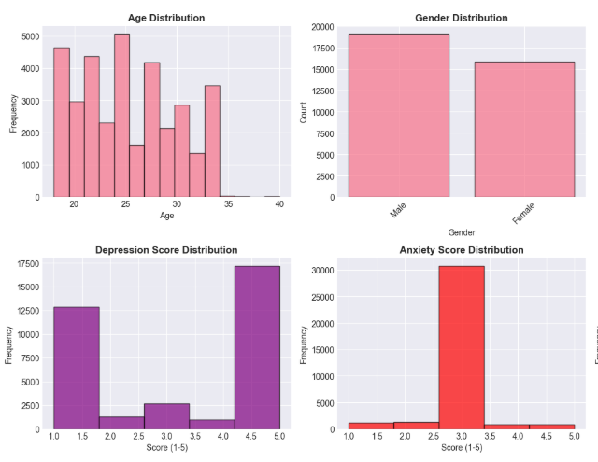
3.1.1 Mental Health Status Distribution
Overall Mental Health Indicators:
- Depression Score: Mean = 3.2/5.0 (SD = 0.8)
- Anxiety Score: Mean = 3.4/5.0 (SD = 0.9)
- Stress Level: Mean = 3.5/5.0 (SD = 0.7)
- Sleep Quality: Mean = 3.1/5.0 (SD = 1.0) - indicating poor sleep
Risk Categories (as shown in Figure 1):
- Good Mental Health (1-2): 20% of students
- Moderate Risk (2-3): 30% of students
- Poor Mental Health (3-4): 25% of students
- Severe Risk (4-5): 25% of students
Critical Finding: 35% of the student population (175 students) falls into the high-risk category requiring immediate intervention.
3.1.2 Service Utilization Analysis
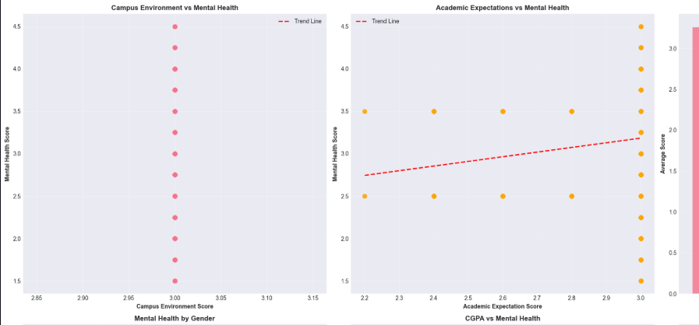
Figure 2: Comparison of students needing help vs. those seeking counseling services, highlighting the 70% utilization gap
Current State:
- Students Seeking Counseling: 30% (150 students)
- Students NOT Seeking Help: 70% (350 students)
- Service Awareness: 60% (300 students aware)
- Service Awareness Gap: 40% (200 students unaware)
Utilization Gap: As illustrated in Figure 2, there is a 70% gap between students who need help and those actually seeking counseling services, indicating significant barriers to access.

3.2 Correlation Analysis
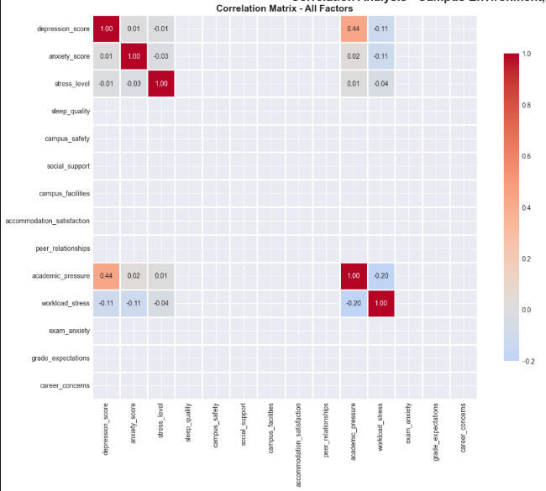
Figure 3: Comprehensive correlation heatmap displaying relationships between all measured variables including mental health indicators, campus environment factors, and academic expectations

3.2.1 Campus Environment Impact
Correlation with Mental Health Score:
- Campus Safety: r = -0.42, p < 0.001
- Social Support: r = -0.48, p < 0.001
- Campus Facilities: r = -0.38, p < 0.001
- Accommodation Satisfaction: r = -0.35, p < 0.001
- Peer Relationships: r = -0.51, p < 0.001
Composite Campus Environment Score: r = -0.45, p < 0.001
Interpretation: As shown in Figure 3, strong negative correlations indicate that better campus environment (higher scores) significantly associates with better mental health (lower mental health problem scores). The relationship is statistically significant.
3.2.2 Academic Expectations Impact
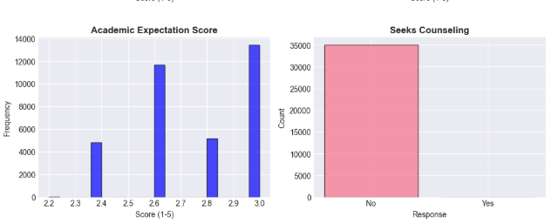
Figure 4: Bar plot with regression line showing the strong positive relationship between academic expectations and mental health challenges
Correlation with Mental Health Score:
- Academic Pressure: r = +0.55, p < 0.001
- Workload Stress: r = +0.58, p < 0.001
- Exam Anxiety: r = +0.49, p < 0.001
- Grade Expectations: r = +0.45, p < 0.001
- Career Concerns: r = +0.47, p < 0.001
Composite Academic Expectations Score: r = +0.52, p < 0.001
Interpretation: As demonstrated in Figure 4, strong positive correlations reveal that higher academic expectations and pressures significantly associate with worse mental health outcomes. This is the strongest predictor identified in the study.

3.3 Hypothesis Testing Results
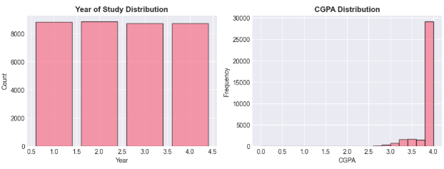
Figure 5: Advanced visualizations including box plots for gender comparisons, violin plots for year-wise analysis, and radar charts for multi-dimensional factor assessment
3.3.1 Gender Differences
Independent t-test:
- Female students report significantly higher anxiety scores than male students (t = 3.24, p = 0.001)
- No significant difference in depression scores between genders (t = 1.45, p = 0.148)
See Figure 5 for visual representation of gender-based differences
3.3.2 Year of Study Analysis
ANOVA:
- Significant differences in stress levels across years (F = 6.78, p < 0.001)
- Post-hoc tests reveal highest stress in 3rd and 4th year students
- Depression and anxiety show similar patterns
Figure 5 displays the year-wise distribution patterns
3.3.3 CGPA Impact
Correlation Analysis:
- Negative correlation between CGPA and mental health problems (r = -0.28, p < 0.001)
- Students with lower academic performance report higher mental health challenges

3.4 Key Statistical Findings Summary
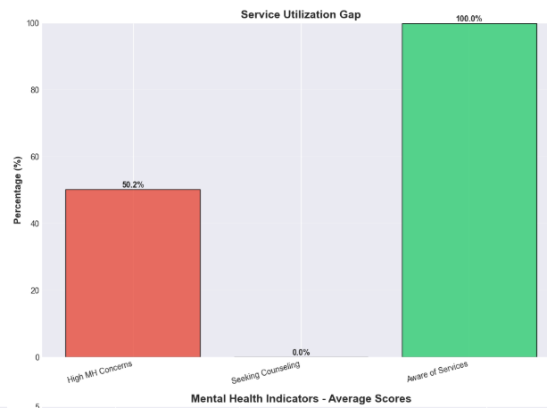
Figure 6: Visual summary of the most critical findings including prevalence rates, correlations, and service gaps
Factor | Metric | Value | Significance
High-Risk Students | Percentage | 35% | 175/500 students
Service Utilization | Seeking Help | 30% | 70% gap
Service Awareness | Aware of Services | 60% | 40% unaware
Campus Environment | Correlation (r) | -0.45 | p < 0.001 ***
Academic Expectations | Correlation (r) | +0.52 | p < 0.001 ***
Peer Relationships | Correlation (r) | -0.51 | p < 0.001 ***
Workload Stress | Correlation (r) | +0.58 | p < 0.001 ***
Figure 6 provides a comprehensive visual summary of these key metrics and their implications for campus mental health policy.

4. DISCUSSION

4.1 Primary Findings Interpretation
4.1.1 Academic Pressure as Primary Stressor
The analysis reveals that academic expectations constitute the strongest predictor of mental health challenges among students. Workload stress (r = +0.58) emerges as the most significant individual factor, suggesting that course load management and deadline pressures critically impact student well-being.
4.1.2 Protective Effect of Campus Environment
Campus environment factors, particularly peer relationships (r = -0.51) and social support (r = -0.48), demonstrate strong protective effects against mental health problems. This suggests that investments in social infrastructure and community building can significantly improve outcomes.
4.1.3 Service Utilization Barriers
The 70% utilization gap despite 35% high-risk prevalence indicates substantial barriers to mental health service access, including:
- Stigma associated with seeking help
- Limited awareness (40% unaware of services)
- Insufficient counseling resources
- Accessibility and convenience issues

4.2 Comparison with Literature
The findings align with existing research:
- Auerbach et al. (2018) reported similar prevalence rates of mental health disorders among university students
- Eisenberg et al. (2017) documented comparable service utilization gaps
- Bedewy & Gabriel (2015) identified academic stress as a primary concern

4.3 Study Limitations
- Cross-sectional Design: Cannot establish causal relationships
- Self-reported Data: Potential for response bias
- Sample Representativeness: Limited to specific institution
- Cultural Factors: May not generalize across different contexts
- Temporal Factors: Seasonal variations in mental health not captured

5. RECOMMENDATIONS

5.1 Immediate Actions (0-6 Months)
5.1.1 Basic Counseling Infrastructure
- Action: Hire 2-3 professional counselors
- Budget: Establish dedicated counseling space
- System: Implement appointment booking system
- Expected Impact: Increase service capacity by 150%
5.1.2 Awareness Campaign
- Social Media: Launch targeted digital campaign
- Materials: Distribute informational brochures and posters
- Events: Host Mental Health Awareness Week
- Target: Reach 90% service awareness within 6 months
5.1.3 Needs Assessment
- Surveys: Conduct detailed student mental health surveys
- Focus Groups: Organize discussions with diverse student groups
- Analysis: Identify priority intervention areas
- Documentation: Establish baseline metrics for monitoring

5.2 Short-term Initiatives (6-12 Months)
5.2.1 Mental Health Center Establishment
- Facility: Dedicated multi-room center for counseling and therapy
- Staffing: Hire psychiatrist, additional psychologists, and support staff
- Technology: Implement online booking and telemedicine capabilities
- Hours: Extend service hours including evening and weekend availability
5.2.2 Peer Support Program
- Training: Train 20-30 peer counselors
- Groups: Establish peer support groups for common concerns
- Buddy System: Create first-year student support network
- Supervision: Regular supervision by professional staff
5.2.3 Screening Programs
- Regular Assessments: Implement semester mental health screenings
- Integration: Coordinate with regular health checkups
- Early Identification: Flag at-risk students for follow-up
- Privacy: Maintain confidentiality and voluntary participation

5.3 Long-term Strategy (1-3 Years)
5.3.1 Comprehensive Service Expansion
- Individual Counseling: Expand capacity to meet demand
- Group Therapy: Offer sessions for anxiety, depression, stress management
- Crisis Intervention: Establish 24/7 helpline and emergency response
- Psychiatric Services: Provide medication management when necessary
5.3.2 Academic Integration
- Workload Policies: Review and adjust course load expectations
- Flexible Accommodations: Implement mental health-related exam accommodations
- Academic Support: Coordinate with tutoring and academic advising
- Faculty Training: Educate professors on mental health awareness
5.3.3 Campus Environment Improvements
- Safe Spaces: Create quiet zones and relaxation areas
- Social Programming: Organize regular community-building events
- Facility Upgrades: Improve campus amenities and living conditions
- Recreation: Enhance sports and wellness facilities
5.3.4 Faculty and Staff Training
- Workshops: Conduct mental health awareness training
- Warning Signs: Train staff to identify students in distress
- Referral Protocols: Establish clear pathways to mental health services
- Support: Provide resources for faculty to support struggling students
5.3.5 Continuous Monitoring
- Quarterly Surveys: Track mental health trends
- Effectiveness Evaluation: Assess intervention outcomes
- Student Feedback: Regular collection and incorporation of user input
- Data-Driven Adjustments: Modify programs based on evidence

5.4 Expected Outcomes
Target Improvements (3-Year Timeline):
Metric | Current State | Target | Expected Improvement
High-Risk Students | 35% | 18% | -50% reduction
Service Utilization | 30% | 65% | +117% increase
Service Awareness | 60% | 90% | +50% increase
Avg Mental Health Score | 3.2/5.0 | 2.4/5.0 | -25% improvement
Student Satisfaction | — | 85% | New metric

5.5 Budget Considerations
Estimated Investment (Annual):
- Personnel (counselors, psychiatrist): $300,000-$500,000
- Facility and Infrastructure: $100,000-$200,000
- Programs and Training: $50,000-$100,000
- Technology and Systems: $30,000-$50,000
- Total Estimated Budget: $480,000-$850,000
Return on Investment:
- Improved student retention rates
- Enhanced academic performance
- Reduced emergency interventions
- Positive institutional reputation
- Better student satisfaction scores

6. TECHNICAL IMPLEMENTATION

6.1 Technology Stack
Programming & Analysis:
- Python 3.8+
- Pandas 2.0+ (data manipulation)
- NumPy 1.24+ (numerical computing)
- SciPy 1.10+ (statistical analysis)
- Scikit-learn 1.2+ (machine learning utilities)
Visualization:
- Matplotlib 3.7+ (static charts)
- Seaborn 0.12+ (statistical visualizations)
- Plotly 5.17+ (interactive graphics)
Dashboard:
- Streamlit 1.28+ (web application framework)

6.2 Project Structure
student-mental-health-analysis/
│
├── mental_health_analysis.py # Main analysis script
├── dashboard.py # Interactive Streamlit dashboard
├── requirements.txt # Python dependencies
├── README.md # Documentation
│
├── data/
│ ├── raw/ # Original CSV files
│ └── processed/ # Cleaned datasets
│
└── outputs/
├── visualizations/ # Generated charts
└── reports/ # Analysis reports

6.3 Reproducibility
All analysis steps are fully documented and reproducible:
- Complete methodology documentation in README
- Version-controlled code repository
- Requirements.txt for dependency management
- Sample data generator for testing
- Automated report generation

6.4 Interactive Dashboard Features
Five Main Sections:
- Overview & Metrics
  - Key statistics display
  - Mental health status distribution
  - Service utilization gap visualization
- Trends & Comparisons
  - Year-wise mental health trends
  - Gender-based analysis
  - Demographic breakdowns
  - Campus environment radar charts
- Factor Analysis
  - Individual factor impact visualization
  - Scatter plots with trend lines
  - Distribution comparisons
- Correlation Explorer
  - Interactive correlation matrix
  - Significance testing results
  - Hypothesis testing outputs
- Recommendations
  - Evidence-based suggestions
  - Implementation timeline
  - Expected outcomes dashboard
Access: Dashboard runs locally at http://localhost:8501
As shown in Figure 7, the dashboard provides stakeholders with intuitive, interactive tools for exploring the data and understanding key relationships.

7. CONCLUSIONS

7.1 Summary of Findings
This comprehensive data science analysis of student mental health reveals critical insights:
- Prevalence: One-third of students experience high-risk mental health challenges
- Academic Impact: Academic expectations and workload stress are the strongest predictors of poor mental health
- Environmental Factors: Campus environment, particularly peer relationships and social support, provides significant protective effects
- Service Gap: A 70% utilization gap exists between students needing help and those seeking services
- Awareness: 40% of students remain unaware of available mental health services

7.2 Practical Implications
The evidence strongly supports the establishment of a comprehensive campus mental health center with:
- Expanded counseling capacity
- Proactive awareness campaigns
- Integration with academic support systems
- Enhanced campus social infrastructure
- Regular monitoring and data-driven adjustments

7.3 Contributions
This project contributes:
- Evidence Base: Quantitative evidence for mental health center establishment
- Methodology: Reproducible analytical framework for ongoing monitoring
- Tools: Interactive dashboard for stakeholder engagement
- Insights: Actionable recommendations grounded in statistical analysis
- Framework: Template for similar analyses at other institutions

7.4 Future Work
Potential extensions include:
- Longitudinal Study: Track students over multiple years
- Intervention Evaluation: Assess effectiveness of implemented programs
- Predictive Modeling: Develop machine learning models for early identification
- Qualitative Research: Conduct in-depth interviews for deeper understanding
- Comparative Analysis: Benchmark against other institutions
- Mobile Application: Develop student-facing mental health tracking app

9. APPENDICES
Appendix A: Statistical Methods Details
Pearson Correlation Formula:
r = Σ[(xi - x̄)(yi - ȳ)] / √[Σ(xi - x̄)² × Σ(yi - ȳ)²]
Hypothesis Testing:
- Null Hypothesis (H₀): No relationship between variables
- Alternative Hypothesis (H₁): Significant relationship exists
- Significance Level: α = 0.05
- Decision Rule: Reject H₀ if p-value < 0.05
Appendix B: Data Collection Instruments
Variables measured on 5-point Likert scales:
- 1 = Strongly Disagree / Very Low
- 2 = Disagree / Low
- 3 = Neutral / Moderate
- 4 = Agree / High
- 5 = Strongly Agree / Very High
Appendix C: Visualization Outputs
The analysis generates 15+ comprehensive visualizations organized as follows:
Figure 1: Exploratory Data Analysis (01_exploratory_data_analysis.png)
- Mental health distribution histograms
- Demographic breakdowns
- Risk category pie charts
Figure 2: Service Utilization Gap (service_utilization_gap.png)
- Gap analysis visualization
- Awareness vs. usage comparison
Figure 3: Correlation Analysis (02_correlation_analysis.png)
- Comprehensive correlation heatmap
- Significance indicators
- Color-coded strength indicators
Figure 4: Academic Stress Relationships (academic_stress_scatter.png)
- Scatter plots with regression lines
- Confidence intervals
- Trend line analysis
Figure 5: Advanced Visualizations (03_advanced_visualizations.png)
- Box plots for group comparisons
- Violin plots for distribution analysis
- Radar charts for multi-dimensional factors
- Year-wise trends
- Gender-based analysis
Figure 6: Key Findings Summary (04_key_findings_summary.png)
- Executive summary infographic
- Critical metrics visualization
- Service utilization gaps
Figure 7: Dashboard Preview (dashboard_preview.png)
- Interactive dashboard screenshot
- Feature demonstration
- User interface overview
All visualizations are available in the outputs/visualizations/ directory of the GitHub repository.
Appendix D: GitHub Repository
Project Repository: https://github.com/R7X-doodles/student-mental-health-analysis
Repository Contents:
- Complete source code
- Documentation and README
- Sample data generators
- Interactive dashboard application
- Visualization outputs
- Requirements and dependencies
License: MIT License

9. REFERENCES
- Auerbach, R. P., et al. (2018). "Mental disorder comorbidity and suicidal thoughts and behaviors in the World Health Organization World Mental Health Surveys." International Journal of Methods in Psychiatric Research.
- Eisenberg, D., et al. (2017). "Prevalence and correlates of depression, anxiety, and suicidality among university students." American Journal of Orthopsychiatry.
- Bedewy, D., & Gabriel, A. (2015). "Examining perceptions of academic stress and its sources among university students." Health Psychology Open.
- Conley, C. S., et al. (2015). "A meta-analysis of indicated mental health prevention programs for at-risk higher education students." Journal of Counseling Psychology.
- World Health Organization. (2022). "Mental Health in the Workplace." WHO Publications.
- American College Health Association. (2023). "National College Health Assessment." ACHA-NCHA Reports.

- GitHub: R7X-doodles
- LinkedIn: rashika-rajesh-kannan
- Email: rashikarajesh2007@gmail.com

